**Topics: Descriptive Statistics and Probability**

1. Look at the data given below. Plot the data, find the outliers and find out $μ, σ, σ^{2}$

|  |  |
| --- | --- |
| **Name of company** | **Measure X** |
| Allied Signal | 24.23% |
| Bankers Trust | 25.53% |
| General Mills | 25.41% |
| ITT Industries | 24.14% |
| J.P.Morgan & Co. | 29.62% |
| Lehman Brothers | 28.25% |
| Marriott | 25.81% |
| MCI | 24.39% |
| Merrill Lynch | 40.26% |
| Microsoft | 32.95% |
| Morgan Stanley | 91.36% |
| Sun Microsystems | 25.99% |
| Travelers | 39.42% |
| US Airways | 26.71% |
| Warner-Lambert | 35.00% |

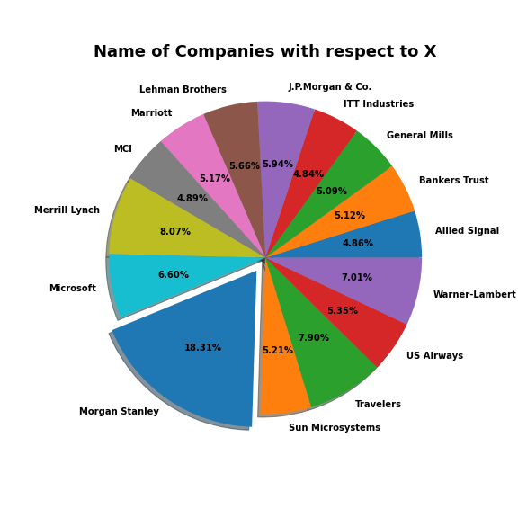

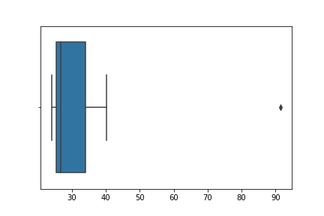

The outlier in the boxplot is : Morgan Stanley – 91.36%

Mean = 33.27

Standard deviation = 16.94

Variance = 287.14



Answer the following three questions based on the box-plot above.

1. What is inter-quartile range of this dataset? (please approximate the numbers) In one line, explain what this value implies.

**Ans:** First Quartile range (Q1) = 5 , Third Quartile range (Q3) = 12,

Second Quartile range (Median) = 7

Inter Quartile Range (IQR) = Q3 – Q1 = 12 – 5 = 7

Therefore, The IQR is the Median.

1. What can we say about the skewness of this dataset?

**Ans:** The above dataset is right-skewed.

1. If it was found that the data point with the value 25 is actually 2.5, how would the new box-plot be affected?

**Ans**: If the datapoint has a value of 2.5, the dataset won’t have any outliers and it would be a normal distribution.



Answer the following three questions based on the histogram above.

1. Where would the mode of this dataset lie?

**Ans:** The mode of this dataset would lie in between 5-10.

1. Comment on the skewness of the dataset.

**Ans:** The dataset is Right-skewed.

1. Suppose that the above histogram and the box-plot in question 2 are plotted for the same dataset. Explain how these graphs complement each other in providing information about any dataset.

**Ans:** Both the boxplot and the histogram are right-skewed and have outliers. In the boxplot, Median is visible while in the histogram, mode is visible.

1. AT&T was running commercials in 1990 aimed at luring back customers who had switched to one of the other long-distance phone service providers. One such commercial shows a businessman trying to reach Phoenix and mistakenly getting Fiji, where a half-naked native on a beach responds incomprehensibly in Polynesian. When asked about this advertisement, AT&T admitted that the portrayed incident did not actually take place but added that this was an enactment of something that “could happen.” Suppose that one in 200 long-distance telephone calls is misdirected. What is the probability that at least one in five attempted telephone calls reaches the wrong number? (Assume independence of attempts.)

Ans: 1 in 200 telephone calls are getting misdirected

Probability of 1 in 200 calls getting misdirected = 1/200

Probability of calls not getting misdirected = 1 – 1/200 = 199/200

Therefore, the probability is atleast one in 5 calls getting misdirected =

n = 5

p = 1/200

q = 199/200

P(x) = (nCx)(p^x)(q^n-x)

P(1) = (1C1)(1/200^1)(199/200)^5-1 ## nCr = n! / r! (n-r)! = 5.

= 5 * 1/200 * (199/200) ^ 4

= 0.0245.

Therefore, the probability of atleast one in 5 telephone calls reaches the wrong person

= 0.0245.

1. Returns on a certain business venture, to the nearest $1,000, are known to follow the following probability distribution

|  |  |
| --- | --- |
| x | P(x) |
| -2,000 | 0.1 |
| -1,000 | 0.1 |
| 0 | 0.2 |
| 1000 | 0.2 |
| 2000 | 0.3 |
| 3000 | 0.1 |

E(X) =Sum X.*P(X) | E(X^2) =X^2*P(X)

-200             | 400000

-100                 | 100000

0             | 0

200       | 200000

600         | 1200000

300         | 900000

Total: 800         | 2800000

1. What is the most likely monetary outcome of the business venture?

**Ans:** The most likely monetary outcome of the business venture is 2000 since its probability is 0.3 which is the highest.

1. Is the venture likely to be successful? Explain

**Ans:** The total probability that the given business venture will yield profit is 0.2 + 0.2 + 0.3 + 0.1 = 0.8 . Hence, There is an 80% chance that the profit will be made. Hence the Venture is 80 % likely to be successful.

1. What is the long-term average earning of business ventures of this kind? Explain

**Ans:** The long-term average is the Expected value = Sum (x* p(x)) = 800 $

This means that on average the returns will be 800$

1. What is the good measure of the risk involved in a venture of this kind? Compute this measure

**Ans:** The good measure of the risk involved in such a venture depends on the variability in the distribution. Higher the variance, more the chances of risk.

Var(x) = E(x^2) – [E(x)]^2

= 2800000 - 800 ^ 2

= 2800000 – 640000

= 2160000